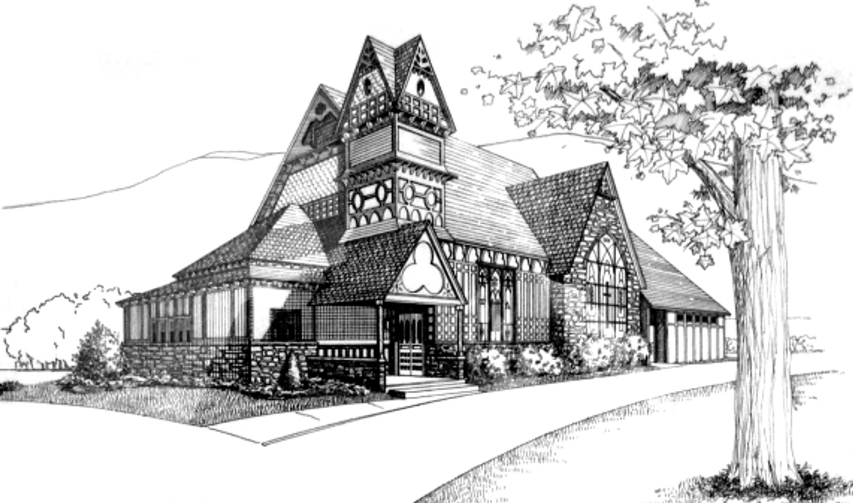  October 2026 Newsletter | First Presbyterian Church of Hawley
Sunday  Worship Service  meets at 10:00am  Sermons:  October 4, 2026  World Wide Communion Sunday  Camp Oneka – 11am  “Resume Advisor”  Romans 13:8-14  October 11, 2026  “Standing in the Breach”  Philippians 3:4-14  October 18, 2026  “Do Me This Service”  Exodus 33:12-23  October 25, 2026  “I Can’t Help It”  I Thessalonians 2:1-8  * * * * * * *  Worship online with Facebook Live:  https://www.facebook. com/ FirstPresHawley | From the Pastor’s Desk…  While Peter was still thinking about the vision, the Spirit said to him, “Look, three men are searching for you. Now get up, go down, and go with them without hesitation, for I have sent them.”  Acts 10:19-20  Moving to a new place, losing a loved one, achieving a long-term goal, experiencing heartbreak, becoming a parent, discovering something you are good at, buying your first home, reading a thought-provoking book, losing everything and starting over, forgiving someone who hurt you, realizing your own strength, breaking a bad habit, experiencing unexpected kindness, and finally letting go of the past.  All of these experiences are transformative moments. They are occasions or opportunities for emotional, mental and spiritual growth. They give us insight, allow us to see the world in a different way, and provide us with the opportunity to change and adjust our map of reality. Transformative moments help us realize the world is bigger than we thought it was, that there are other ways to live, that there is more to life than making money, that we have choices, and that we are capable of far more than we thought possible. And we need such transformative moments, or we will stagnate and never grow up.  Acts chapter 10 records a transformative moment for Peter. Up until this point he has taken the conservative Jewish line of only eating kosher food and more importantly, he will not associate with anyone who is not Jewish. His faith is stuck and the Gospel is confined to a small people group. However, after a repeated rooftop vision Peter is asked, challenged, and pushed to rethink his position. It came as a grand realization that the Gospel Good News was for all.  Before Peter has too much time to dwell on this revelation, (and haven’t we all overthought stuff) God commands him to go down and answer the door. There he is greeted by non-Jewish people and is invited to their home. I imagine Peter was feeling rather uncomfortable. Yet, when he shares the good news within the Gentile household the spirit falls, and all the people come to faith in Jesus Christ. It dawns on Peter that God has bigger plans.  What are some of your transformative moments? How have they have given you more compassion, patience, and understanding? What might God be doing right now that expands your small view of the world? How are you sharing the Good News in a larger context?  By God’s Wondrous Grace,  Pastor Mark Juengel
COMMITTEE NEWS
Committee Chairs  Finance – Bill Rockafellow  Christian Ed – Jill Juengel  Co-Treasurers – Karen Lutz & Jim Brewington  Deacons – John Ehlers  Mission: Jim Mould  Music & Worship – Ann Marie Grilk  Music Director - Matthew Rupcich  Parish Life – Kika Dyson  Session – Rev. Mark Juengel  Personnel – Joe Jauss  Nominating & Clerk of Session – Chris Caruso |  |  |   10/4: Parish Life Meeting (Cancelled)  10/11: Deacons Meeting  10/13: 12:15pm - Worship & Music Mtg.  10/18: 5:30pm – Mission’s Committee Mtg.  10/22: 9am – Finance Mtg  10/27: 12:15pm – Personnel Committee  10/28: 6pm – Session Meeting
* * * * *
Pastor Mark’s Study Leave & Synod Leave
Pastor Mark will be on Study Leave from October 5th – 13th and Synod Leave from October 25th – October 27th.
* * * * *
World Communion Offering at Camp Oneka
October 4th
What does the Lord require of you? “to do justice and to love kindness and to walk humbly with your God…” Micah 6:8

Loving kindness is one of the most beautiful threads woven throughout the Old Testament. Again and again, we are reminded that the people we meet are not strangers or enemies but beloved children of God. The prophet calls us to recognize the inherent worth of every person, to practice welcome and to make room at the table for all God’s children. This is expressed in action, often involving mercy, faithfulness and steadfast commitment.
This year marks the first time congregations across the Presbyterian Church USA are invited to receive the World Communion Offering. Through this new offering, we join with other congregations in supporting the wider church in the work of racial justice, gender justice, peacemaking, global witness, and ecumenical and interfaith relations. In a world that often feels divided, this Offering helps us remember that we belong to one another, even to people we may never meet. We will receive this Offering on Sunday, October 4th.
COMMITTEE NEWS
Nomination Of Members For Church Officers & Committees
The Church Nominating Committee is searching for individuals with the skills and interests needed for service as Elders, Deacons and Committee Members. Nominees should be willing to give meaningful amounts of time in service and leadership. Currently, it is not necessary to secure the permission of another member before submitting a name. If you want to serve, you are encouraged to submit your own name. The Church Nominations Committee will consider all names brought forward. After careful consideration, the committee will then present a slate of nominations at the General Meeting. Nominations are due on Sunday, October 18th. Forms will be available as a Bulletin insert and on the table in the Narthex. Please return completed forms to Chris Caruso. For more information please see Chris Caruso or Pastor Mark.
* * * * *

Stewardship: Love in Action
Romans 12 gives us a beautiful picture of stewardship:
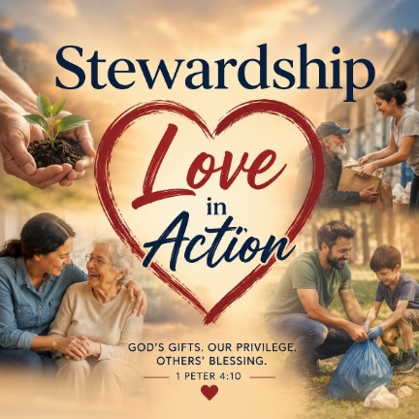
- Love genuinely.
- Honor others.
- Serve faithfully.
- Share generously.
- Practice hospitality.
- Help those in need.
- Persevere in hope.
- Respond to evil with goodness.
This is stewardship as a lifestyle.

When we give our money, we are practicing stewardship. When we give our time, we are practicing stewardship. When we open our homes, use our gifts, encourage another person, forgive someone, or serve our community, we are practicing stewardship.

The goal is not simply to give more. The goal is to love more deeply and serve more faithfully.

God has entrusted each of us with something that can make a difference in the lives of others. The question is not whether we have something to give. The question is whether we are willing to place what we have in God's hands.

Stewardship is love in action. And when love becomes action, God's goodness becomes visible through us.

You will receive a letter in the next couple of weeks from the Stewardship Committee. It will have 3 items, a brochure, a stewardship letter, and a pledge letter. Please read them over and discern how you can support your church in 2027. Please fill in the pledge sheet and return it to the church on Stewardship Sunday, November 8. We will consecrate our gifts together. If you can’t make it on that date, please send your pledge to the church office in care of Bill Rockafellow.

Peace,
The Stewardship Committee
WORSHIP INFORMATION
 | Outdoor Worship Services  at Camp Oneka  October 4th at 11am  Our Friends, John and Rachel Waszczak have invited us to worship at Camp Oneka once again this year. Camp Oneka is located at 325 PA 390, Tafton, PA 18464  Worship will take place in the Camp’s beautiful dining hall. This space is heated, has restrooms, and an accessible ramp. We will have a view of Fairview Lake. Following worship, the camp will provide goodies for our coffee hour. You are free to walk around this historic camp  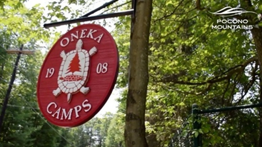   |  |  | Direction to Camp Oneka  325 PA-390  Tafton, PA 18464  From the Church: (815 Church St, Hawley, PA 18428)  - Go to US 6 E  - Turn RIGHT onto 507 past Lake Wallenpaupack.  - Make a LEFT on RT. 390 S.  - Camp Oneka is 2.1 miles after turning on RT 390.  - As you pass Lake Fairview there are two camp entrances. Turn RIGHT at the SECOND entrance. People will direct you from there.  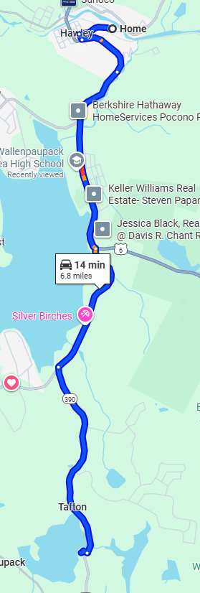
UPCOMING EVENTS
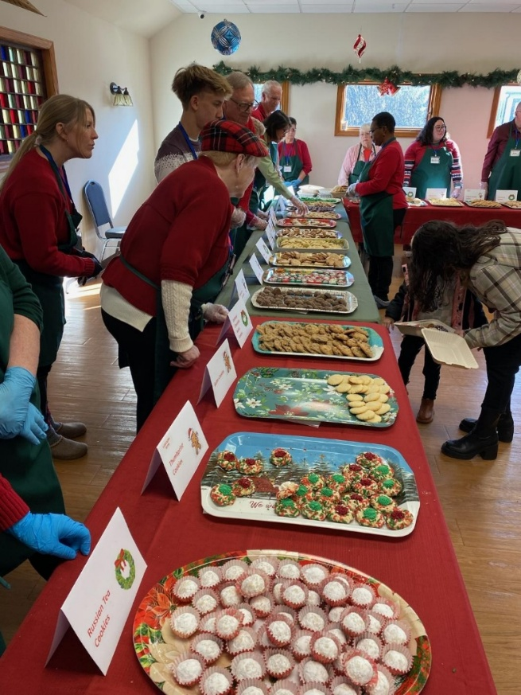 |  |   2026 Cookie Walk  December 12th 9:00am - 12:30pm  This year's Cookie Walk is scheduled for Saturday, December 12th from 9:00 am to 12:30 pm and will be part of the annual Winterfest activities in downtown Hawley. Our Cookie Walk has become a festive and much anticipated event in our community and is also an important fundraiser for the church. But it is also a lot of work - especially for our bakers. We would like to start early to identify our list of bakers this year and would love to see new volunteers. A Sign-up sheet is available in our vestibule. Thank you in advance for being willing to volunteer your time and your baking talents! If you have any questions please contact Karen Lutz (917-612-8824) or Kika Dyson (570-498-0007).
* * * * *
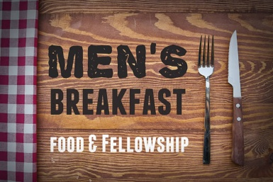
Lori's Corner Kitchen in Hamlin.
630 Hamlin Hwy., Lake Ariel, PA 18436
Wednesday, November 4th
8:00am
Attention all men of the Church. We are organizing a Men’s Breakfast for fellowship and a good meal on November 4th at 8am. This will be a time to relax and enjoy one another’s company. If you like the occasion, we can plan for further get togethers. You can invite a friend. Cost: That is up to you - How many pancakes do you need? If you have further questions, see Joe Jauss or Pastor Mark. Please use Sign-Up Sheet located on the Narthex table. We need to let the restaurant know how many are coming so they can prepare it for us.
UPCOMING EVENTS – Cont’d.

Saturday, October 17th
Doors Open at 4:30pm & Calling Begins at 6:00pm

This year’s Tricky Tray will be on Saturday, October 17th. Doors will open at 4:30pm and calling will begin at 6:00pm. A large number of themed baskets will be available. Refreshments will be available for purchase. Baskets and Gift Card donations are greatly appreciated. If you would like to make a donation, a Sign-Up Sheet has been placed on the table in the Narthex. For more additional information, please see Pat Bartleson.
* * * * *
Synod Of The Trinity Meeting
Omni Inn of Bedford, PA
October 25th -27th
The annual Synod of the Trinity meeting will be held October 25th -27th at the Omni Inn of Bedford, PA. Synod representatives from all of the presbyteries of Pennsylvania and West Virginia will meet for business, worship, and connection. Our focus this year will be on the changing face of mission. Our special guest will be Dr. Scott Hagley, Professor of World Mission and Evangelism.
Reverend Mark is the co-moderator of the Synod and will represent our congregation and presbytery at this gathering. Please keep us in your prayers.
* * * * *

FPCH Red Cross Blood Drive
Wednesday, October 14th
The Red Cross Blood Drive on Wednesday, October 14th from 1pm-6pm. Register to give blood at:
https://www.redcross.org/. To sign up for an appointment call 1-800-Red-Cross or Red Cross Blood.org or Download the Blood Donor App. For more information, please contact Melanie Tek-Visgilio.

UPCOMING EVENTS – Cont’d.


Joanne Weiss and Women’s Retreat
Gratitude As A Spiritual Path
Saturday, October 24th
9:00am to 4:00pm
The Christian Education committee will be sponsoring a women’s retreat on Saturday, October 24th from 9:00am- 4:00pm. We will gather in Blough Hall at 9:00am for some fellowship with coffee, tea and some light refreshments. Our program will begin at 9:30am. We will break for lunch at noon. You are asked to bring your own bagged lunch. We will provide the beverages. Our good friend Rev. Dr. Joanne Weiss will present the theme Gratitude as a Spiritual Path:
All of the Spiritual traditions encourage us to live with a grateful heart. In 1 Thessalonians 5:18 Paul writes, “In everything give thanks for this is the will of God in Jesus Christ for you.” What a challenge, especially when personal and collective suffering is great! While we may want to live in gratitude, much of the time our focus keeps looping in complaints, negativity, and fears despite our best intentions.
This one-day retreat will draw on contemplative traditions, neuroscience, and 21st century tools of psychology to give us practices and tools to cultivate gratitude as a core spiritual practice that changes the way we show up in life in relationship to God, to ourselves, to others, and to the world.
There will be a sign-up sheet on the table in the entry way so we know how many to expect. You are welcome/encouraged to invite a friend. We hope you will join us! If you have any questions please check with Jill Juengel. Join us on Saturday, October 24th for a day to slow down, come home to yourself, and learn some practical ways of being more present in your life with a grateful heart! Mark your calendars. For additional information, please see Jill Juengel.
The Rev. Dr. Joanne G. Weiss lives outside of Lake Ariel, PA. She holds graduate degrees in theology, music, and clinical social work and her professional life over the last 40 years as a college music teacher, pastor and university chaplain, and psychotherapist reflects her varied background. She currently maintains a private practice in Clarks Summit, has led retreats since 1991, and serves as supply pastor throughout the Presbytery.
UPCOMING EVENTS – Cont’d.
Scam Prevention –
Saturday, November 14th
at 1pm
One of the sad realities of life is the prevalence of fraud and scam schemes. Senior citizens are particularly vulnerable. To help protect yourselves, the Wells Fargo Bank is providing an Awareness seminar at our church on Saturday, November 14th at 1:00pm.

Our own Lauren Piccotti and Lynn Graham, Managers at the local Wells Fargo Bank locations in Hawley and Milford will be the day’s presenters.

We will be discussing Fraud and Scam solutions and what you need to know and watch out for. We will also be chatting about Elder Abuse and how scams relate directly to this as well. We will have an open discussion for those who have experienced any scam or have questions. The scam types that are most prevalent right now are as follows:

Tech Support Scams — This scam involves individuals posing as a well-known or trusted technology, software, or anti-virus company. The scammer may claim that your device has been used in a crime, is infected with a virus, or that you’ve made an unexpected payment and they want to return your money.

Government Scams (IRS/Medicare) - Scammers pose as government officials requiring their victims to wire cash, use cryptocurrency, or use prepaid debit or gift cards to pay a bogus tax bill. Or they may provide sham Medicare services at makeshift mobile clinics in order to bill the insurance and pocket the money.

Family Scams — Fraudsters play to the emotions of family members by identifying themselves as grandchildren calling about an emergency situation. They may say, “I’ve been arrested and need money wired quickly,” or “I need cash cards for bail.” They may even use Artificial Intelligence to mimic a loved one’s voice.

Prize & Sweepstakes Scams — Under the guise of a telemarketing call to notify the winner of a lottery or sweepstakes, the victim is told they must pay taxes on the jackpot in person, by mail or wire before they can claim their prize.

Romance Scams —With the false promise of love and companionship, a person is conned into trusting a new “friend” they meet through social media, dating apps, or even in person. The romantic partner then swindles them out of money and/or property before disappearing.

Scammers make billions of dollars a year. You may prevent yourself or a loved one from being a victim. Come join us. Please sign up in the Narthex. If you have a question, please see Lauren Piccotti or Pastor Mark.

WORSHIP VOLUNTEERS – OCTOBER
Volunteers Needed
If you would like to volunteer, please Sign-Up in the vestibule to be an Usher and to host Coffee Hour. For Liturgists, see Adele Harrison, and to help with Communion, see Ann Marie Grilk.
October - Coffee Hour  10/4: Camp Oneka  10/11: TBD  10/18: TBD  10/25: TBD | October - Flower Donations  10/4: Ann Marie Grilk  Camp Oneka  10/11: TBD  10/18: TBD  10/25: TBD |  | October  Good News Café  10/10: Don & Maria McArthur  10/24: Cancelled
****  October - Liturgists  10/4: Nancy Vignau  (Camp Oneka)  10/11: Jim Mould  10/18: Sue Goldbach  10/25: Jill Juengel | ****  October - Ushers  10/4: Grace & Herb Laird  (Camp Oneka)  10/11: Don Granza &  Janet Steifel  10/18: TBD  10/25: TBD |  | ****  October - Communion Servers at Camp Oneka  (October 4th)  Servers: Pat Bartleson  Kathleen Roberts
CHURCH LIFE
Donate to FPCH
Thank you for your continued financial support. You may use the church’s website: (https://www.fpchawley.org) or feel free to send a check directly to the church at 815 Church Street, Hawley, PA. Your support is appreciated.
* * * * *
M&M Group Study  The M&M Group meets Monday’s at 11:00am at the home of Betsy Yergey, 27 Lake Drive, Hawley. For a curriculum see the Study Sheet from the previous Sunday sermon. All are welcome. |  | Joys & Concerns  For a most recent Prayer List, please go to the Church’s website at https://www.fpchawley.org/
CHURCH LIFE – Cont’d.
Good News Café  The Good News Café will be on October 10th . The Good News Café will be cancelled on October 24th the Woman’s Retreat will be taking place on that day. The Good News Café will resume on November 14th. As always, a seated lunch meal is provided. The Café is open on the 2nd and 4th Saturday of each month from 11:30am–1:00pm. Please direct questions concerning signing up to cook a meal or to help serve Eileen Brewington, Pat Gemeinhardt or Karen Rockafellow. Your help and support are much appreciated.  * * * * *  Books  There is a bookcase full of books in the Social Hall. Please feel free to take them home. | Home Communion  Pastor Mark is giving Home Communion on the first Sunday of each month. If you are homebound and would like to receive communion please contact the church office the week before. Communion will be received in the afternoon following worship.  * * * * *    The Book Club meeting is on Friday, October 16th. The September Book is Seven Reasons to Murder Your Dinner Guests by Kit Whittle (Betsy). If you would like to know more about our Book Club, please contact Melanie Tek-Visgilio.
* * * * *  November Newsletter  Our next Newsletter will be in November 2026. Articles for our next monthly Newsletter need to be in the office by Wednesday, October 14th. The Newsletter will go to print on the 26th of each month. Any articles submitted after the 26th will go on the following month’s Newsletter.  * * * * *  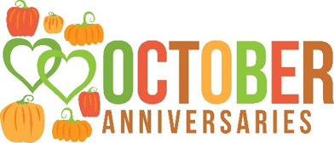  10/23: Kenneth & Janine Smith  10/26: Joseph & Sue Hare and  Albert & Janet Stiefel | * * * * *  Office Hours  Monday–Thursday  8:00am-1:00pm  Closed Fridays  * * * * *    10/3: Jody Koch  10/8: Sue Hare  10/12: Betsy Falk  10/16: Ben Cumberland  10/21: John Ehlers & Robert Pinkney  10/31: Henry Rugen
COMMUNITY EVENTS
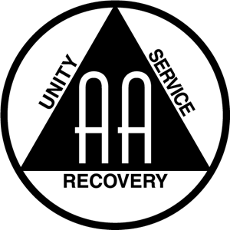  For those in need of support the church hosts AA meetings, every Monday and Wednesdays at 12:00pm.  * * * * * |   The Lion’s Club  The Lion’s Club will be meeting Thursday, October 15th. For more information, please contact Pat Bartleson.  * * * * *
The Wayne Highlands Quilt Guild    The Wayne Highlands Quilt Guild October meeting will meet in Blough Hall on October 19th from 4:00pm to 6:00pm. We will have a short business meeting followed by 'sew and tell', a small project to work on, and time to visit with one another. Anyone interested in quilting is invited to join us. For more information contact Deb Jacobson at:  debszoo@gmail.com   | 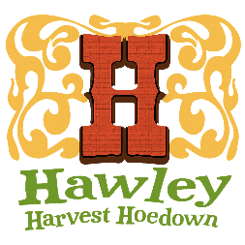  Hawley Harvest Hoedown  Saturday, October 3rd  11am-5pm  The church would like to participate in the annual Hawley Harvest Hoedown on Saturday, October 3rd and we need volunteers. We will have morning and afternoon shifts available. If you are able to volunteer, please sign up using the Sign-Up sheet in the entryway or contact Jim Mould.  
OCTOBER 2026
Sun | mon | tue | wed | thu | fri | sat
 |  |  |  | 1 | 2 | 3
 |  |  |  | 11am: Bible Study | 12pm: Wedding  Setup | 11am-5pm Hawley Harvest Hoedown  2pm: Wedding
4 | 5 | 6 | 7 | 8 | 9 | 10
World Communion Sunday  Pastor Mark – Study Leave 10/5-10-13  Camp Oneka  9am: Chancel Choir  Reh.  10am: Worship  11am: Coffee Hr.  Parish Life Mtg.  (Cancelled) | 11:am: M&M Grp.  Mtg.  12pm: AA | 10am: Handbell Choir  11am: Chancel Choir | 12pm: AA  5-8pm: Cub Scouts  6:30pm: Prayer Grp.  (Cancelled) | 11am: Bible Study |  | 11:30am-1pm:  Good News  Café
11  Pastor Mark – Study Leave 10/5-10-13 | 12 | 13 | 14 | 15 | 16 | 17
9am: Chancel Choir  Reh.  10am: Worship  Deacon’s Mtg. | Columbus Day  11:am: M&M Grp.  Mtg.  12pm: AA | 10am: Handbell Choir  11am: Chancel Choir  12:15: Worship  & Music Mtg | 12pm: AA  5-8pm: Cub Scouts  1pm-6pm: Red Cross Blood Drive  6:30pm: Prayer Grp. | 11am: Bible Study  5:30pm-8pm:  Lion’s Club | 1pm: Book  Club | Tricky Tray  4:30pm Doors open  6:00pm: Calling begins
18 | 19 | 20 | 21 | 22 | 23 | 24
Congregational Meeting  9am: Chancel Choir  Reh.  10am: Worship  Missions Mtg.  Congregational Mtg. | 11:am: M&M Grp.  Mtg  12pm: AA  4pm-6pm: WH  Quilters | 10am: Handbell Choir  11am: Chancel Choir | 12pm: AA  5-8pm: Cub Scouts  6:30pm: Prayer Grp. | 9am: Finance  Mtg:  11am: Bible Study |  | 9am-4pm: Woman’s Retreat (Blough Hall)  11:30am-1pm:  Good News  Café (Cancelled)
25 | 26 | 27 | 28 | 29 | 30 | 31
9am: Chancel Choir  Pastor Mark – Synod Leave  Reh.  10am: Worship | 11:am: M&M Grp.  Mtg  12pm: AA | 10am: Handbell Choir  11am: Chancel Choir  12:15pm: Personnel  Mtg.  . | 12pm: AA  5-8pm: Cub Scouts  6:00pm: Session  Mtg  6:30pm: Prayer Grp.  (Cancelled) | 11am: Bible Study |  | Halloween  Pastor Mark – Vacation 10/5-10-13  
